WSAB - Version 4.1 Parts List (2025/02/10)
C1 10uf 16vdc Jameco 94060
C2 10uf 16vdc Jameco 94060
C3 .01uf Jameco 15229
C4 .01uf Jameco 15229
C5 47uf Jameco 135319
C6 47uf Jameco135319
C7 10uF 25vdc Jameco 94060
C8 .047uf Jameco 15253
C9 .047uf Jameco 15253
C10 .0047uf Jameco 15211
C11 .01uf Jameco 15229
C12 .01uf Jameco 15229
C13 .01uf Jameco 15229
C14 4.7uf 25vdc Jameco 546071
C15 4.7uf 25vdc Jameco 546071
C16 4.7uf 25vdc Jameco 546071
C17 4.7uf 25vdc Jameco 546071
DIPSW1 Jameco 696950
DSP1 TFT Display Amazon 1.8 "TFT Search for "ASIN:B0C2HNVSWV" (11-pin connector)* See Note
FS1 AD9850 Module Amazon HiLetgo DDS AD9850 Search for “ASIN:B01J7XPWNU”
J1 RCA Phono Jack Mouser 806-KLPX-0848-2-W
J2 RCA Phono Jack Mouser 806-KLPX-0848-2-W
J3 DC Jack Jameco 2210677
MP1 Arduino Pro MiniAmazon Search for “ASIN:B07X2JGS69”
Q1 2N3904 Jameco 38359
R1 47k Jameco 691260
R2 22k Jameco 691180
R3 1k Jameco 690865
R4 1k Jameco 690865
R5 2k Jameco 690937
R6 3.9k Jameco 691008
R7 8.2k Jameco 691083
R8 1k Linear Pot Jameco 2271663
R9 1M Linear Pot Jameco 2271679
R10 100k Jameco 691340
R11 100k Jameco 691340
R12 15k Jameco 691147
R13 16.9k 1% Mouser 660-MF1/4CC1692F
R14 50K Linear Pot Jameco 853791
R15 47k Jameco 691260
REN1 Rotary Encoder Amazon Cylewet KY-040 ASIN:B06XQTHDRR
REN2 Rotary Encoder Amazon Cylewet KY-040 "
SW1 DPDT Slide Swt Jameco 161817
SW2 PB Switch Jameco 149948
SW3 PB Switch Jameco 149948
U1 LM7805CV Jameco 51262
U2 TLE2021 Mouser 595-TLE2021CPE4
U3 MAX680 Mouser 700-MAX680CPA
Heat Sink Jameco 158051
24-pin IC Socket Jameco 112264
20-pin IC Socket Jameco 112248
8-pin IC Socket x 3 Jameco 51571
PCB WSAB 4.1 eBay
* Important! Several versions of the 1.8" TFT display show up on Amazon. The correct one has only 11 connector pins. At this time, the one listed should be the correct one. Nevertheless, double-check that it has only 11 connector pins before ordering.
Initial Power-Up Checks
1. When PCB is populated except for the AD9850, Arduino, and TFT Display, check the voltages on the points indicated below.
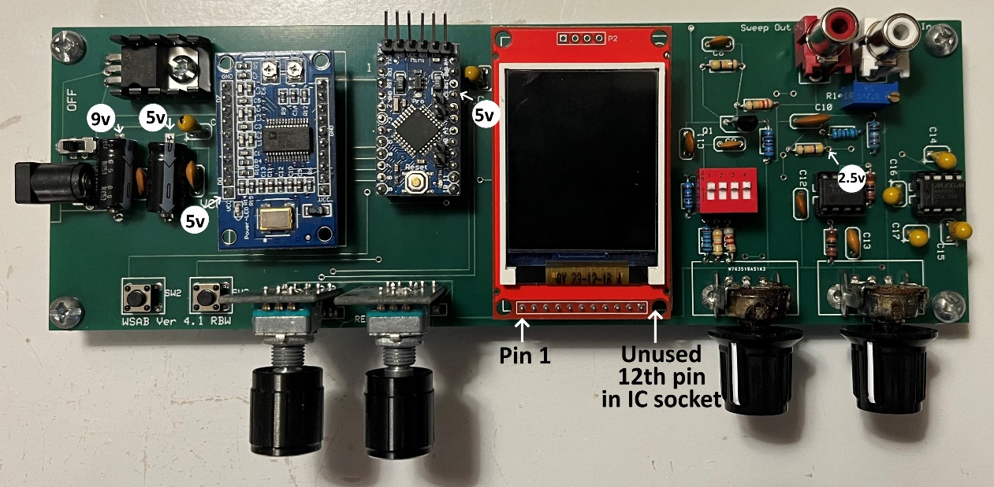
2. With the sweep input grounded, adjust trimpot R1 to give 2.5 volts at the junction of R12 and R15.
Install Final Devices
Install the AD9850 and Arduino so that the VCC pins match the labels on the PCB. The TFT Display has only 11 pins, while the standard socket has 12 pins. Install the TFT Display so that its pin 1 is aligned with the left-most socket pin as shown.
Questions? Contact me at this email: whipplewaytx@gmail.com

